

**TEAM**

**1**

**Medical Report Generator**

**BVRIT HYDERABAD**

**College of Engineering for Women**

**Department of Information Technology**

**Mini Project - Academic Year 2019-20**

**Abstract**

Medical Report Generator is an android application and it is also called as pathology reporting software. This Software is the easiest for Pathology Lab and Diagnostic Laboratories. This software gives high qualitylab report printing and provides efficient management of lab records. It can make your laboratory report generation and accounts management job much simpler and quicker. The main aim of developing this application is to reduce the time to a great extent that is spent in keeping and maintaining records.

**Web 2.0 technologies made users to spend more time on the Internet to search for answers about various questions.**

**16WH1A1202**

**A.Bhavishya**

**16WH1A1232**

**K.Bindu Sri**

**16WH1A1246**

**M.Sriyasri**

**Tools and Technologies**

* **Android SDK**
* **SQLite**

**Conclusion and Future Scope**

Our project is a user-friendly, live sample of how diagnostic reports are generated by the diagnostician. Since, it is an android application, the user can work on it at their best comfort. Few credentials like login time and date are triggered in the report for an easy reference. We have described the requirement specifications that are needed for the application. Finally, the application is implemented and tested against the test cases. In addition to this, we can also include the modules of billing, printing the report for further user-friendly.

of this application will greatly reduce time at the time of diagnosis

**Guide**

**Mr. L Naveen Kumar**

**Assistant Professor of IT**

**naveenkumar.l@bvrithyderabad.edu.in**

**Team**

**Outputs:**

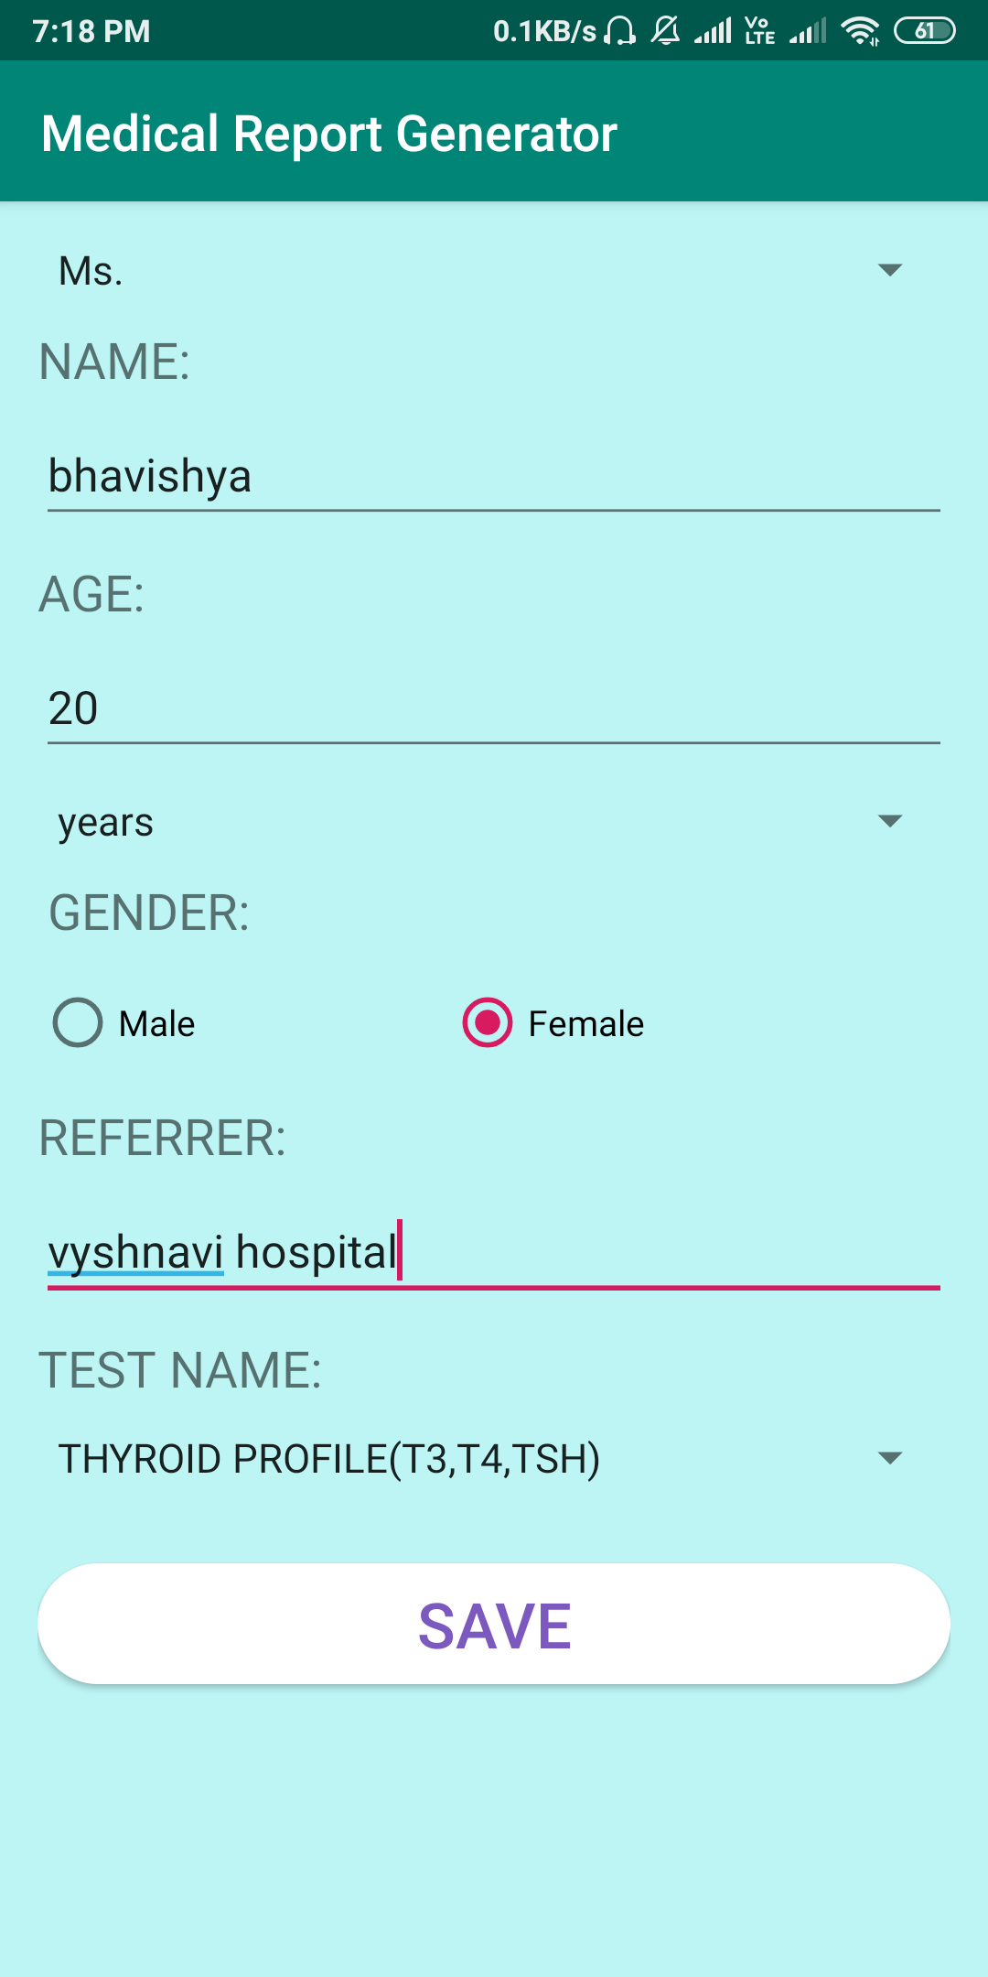 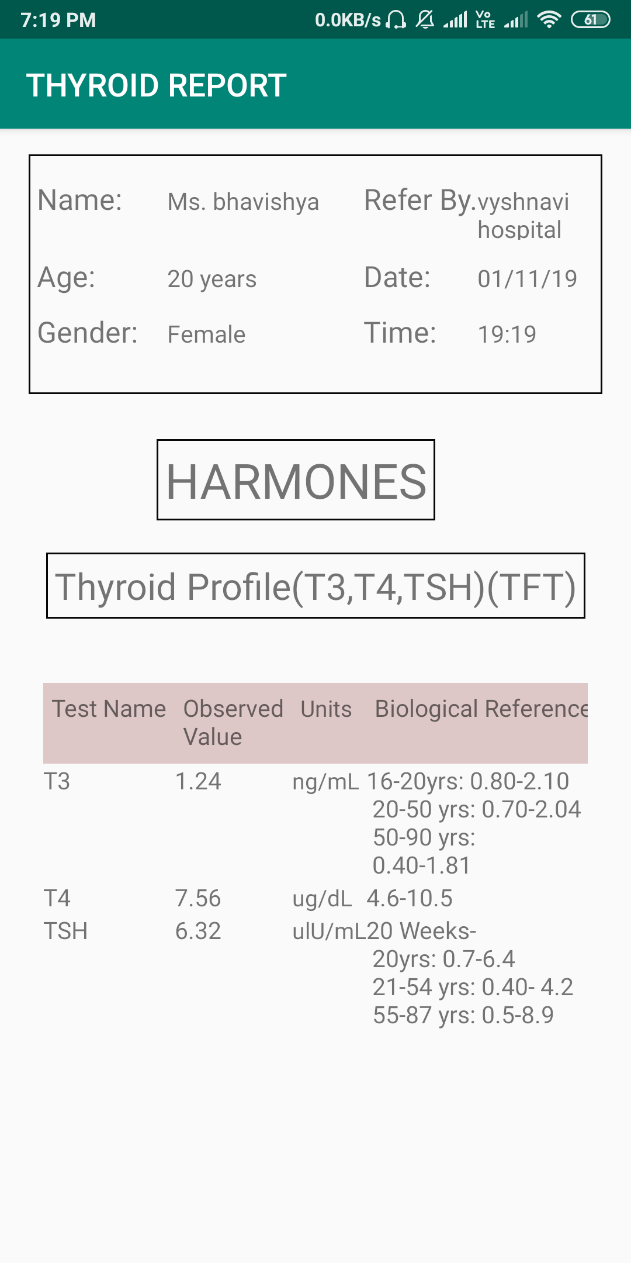

**Architecture**



